|  |
| --- |
| FileZilla Installation |

Steps for installation of the FileZilla Tool

Step 1:- Login to the CRDR homepage

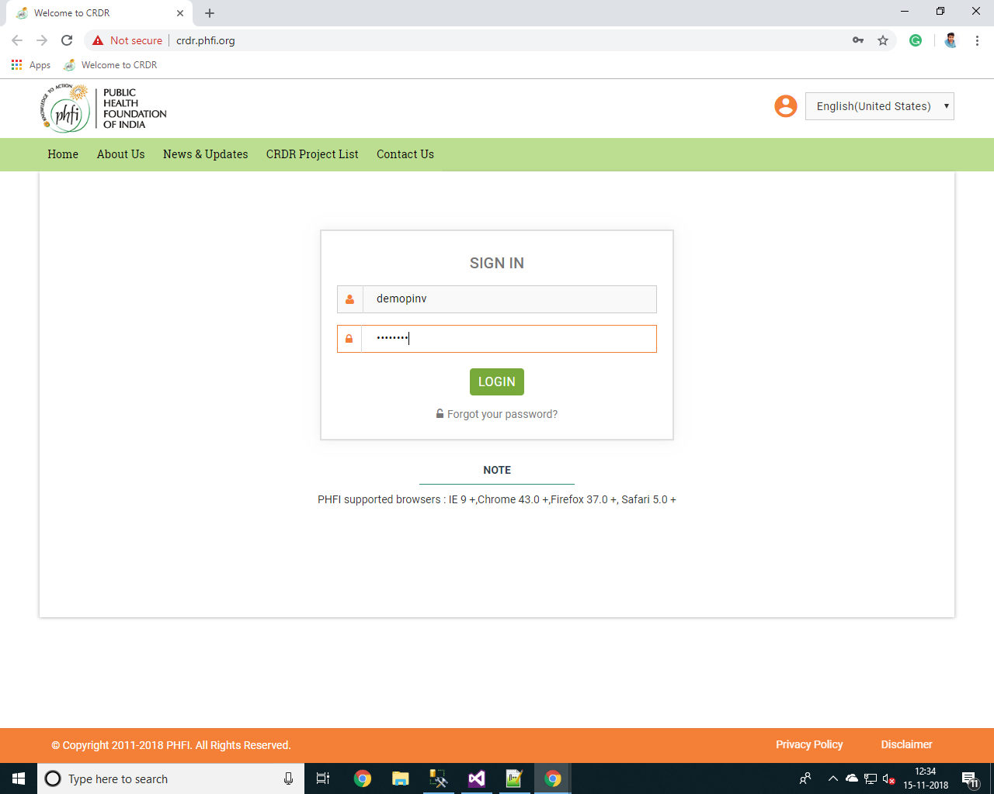

Result:- Pass.

Step 2 :- User is navigated to the dashboard, after logging in

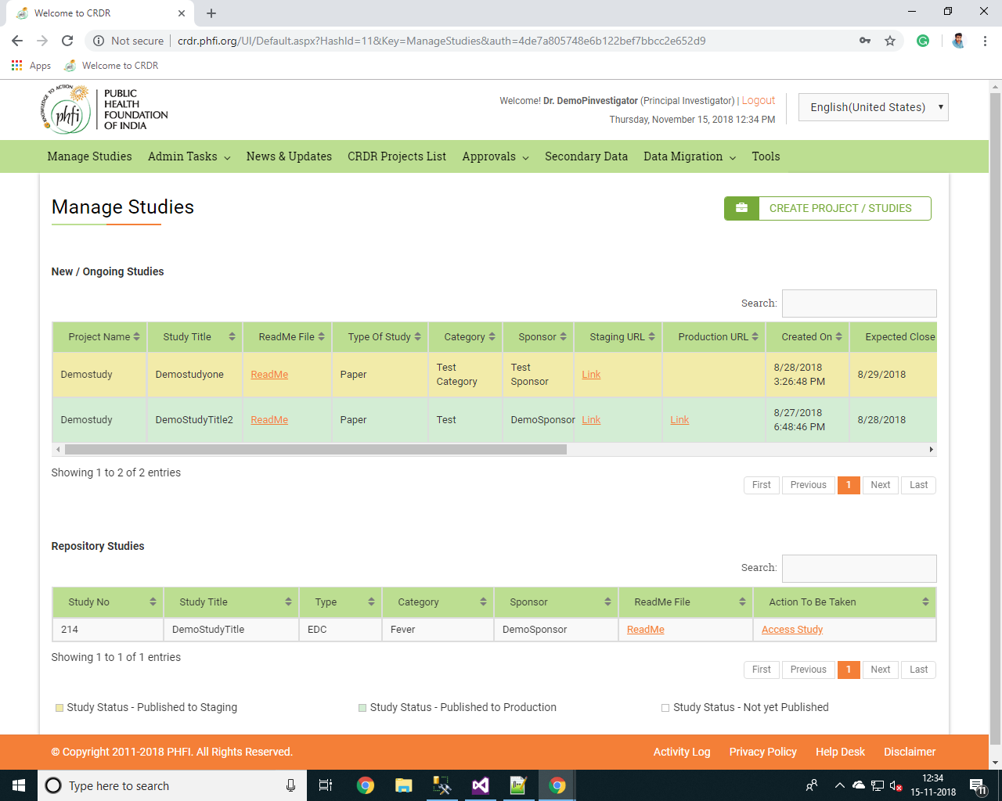

Result:- Pass.

Step 3 :- Select the ‘Tools’ link in the Header.

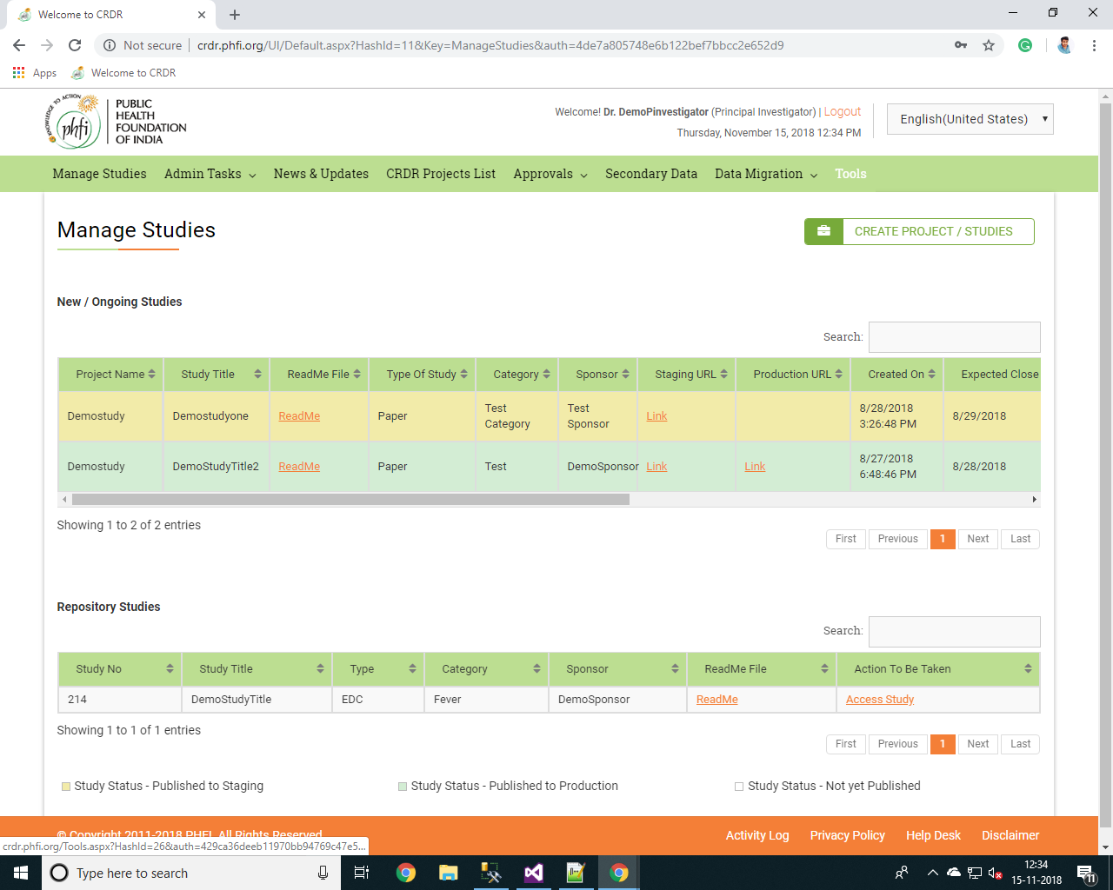

Result:- Pass.

Step 4 :- it will be navigate to the page ‘https://filezilla-project.org/download.php’ and select the ‘Download FileZilla Client’.

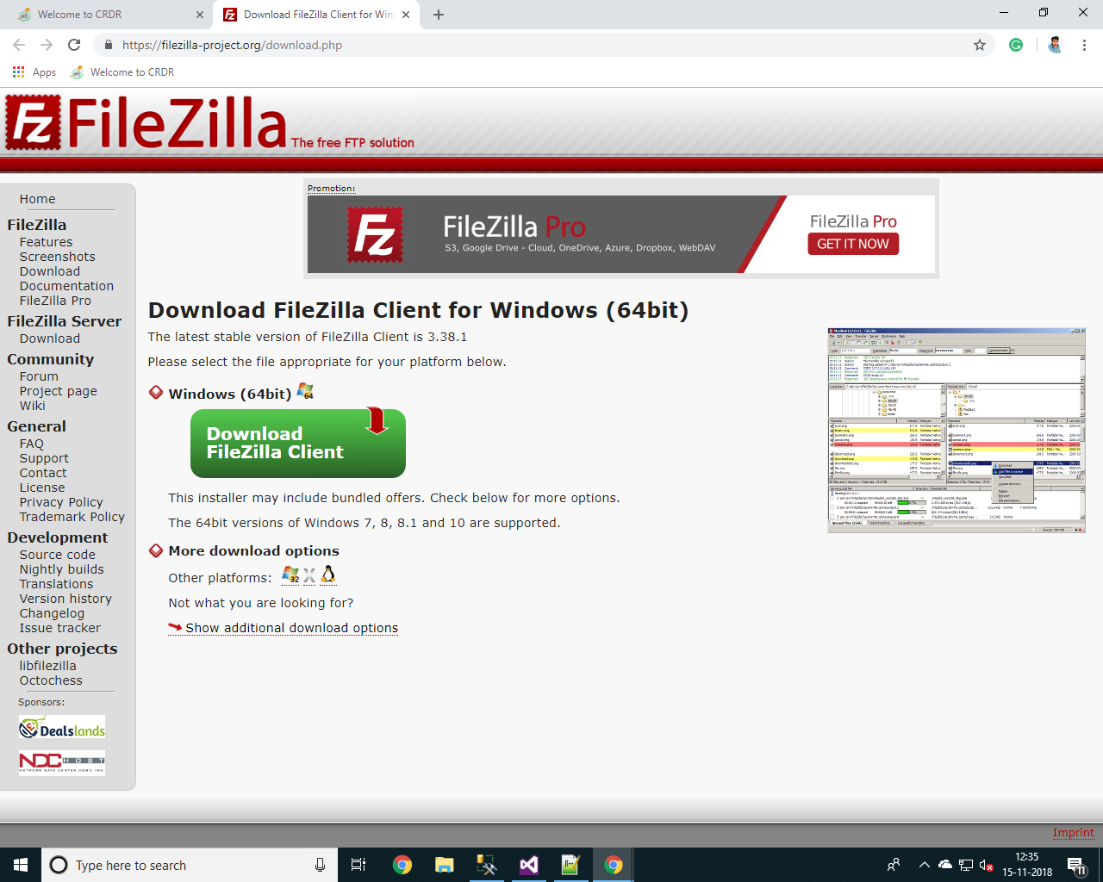

Result:- Pass.

Step 5 :- Select the ‘Download’ in the Edition of FileZilla Client.

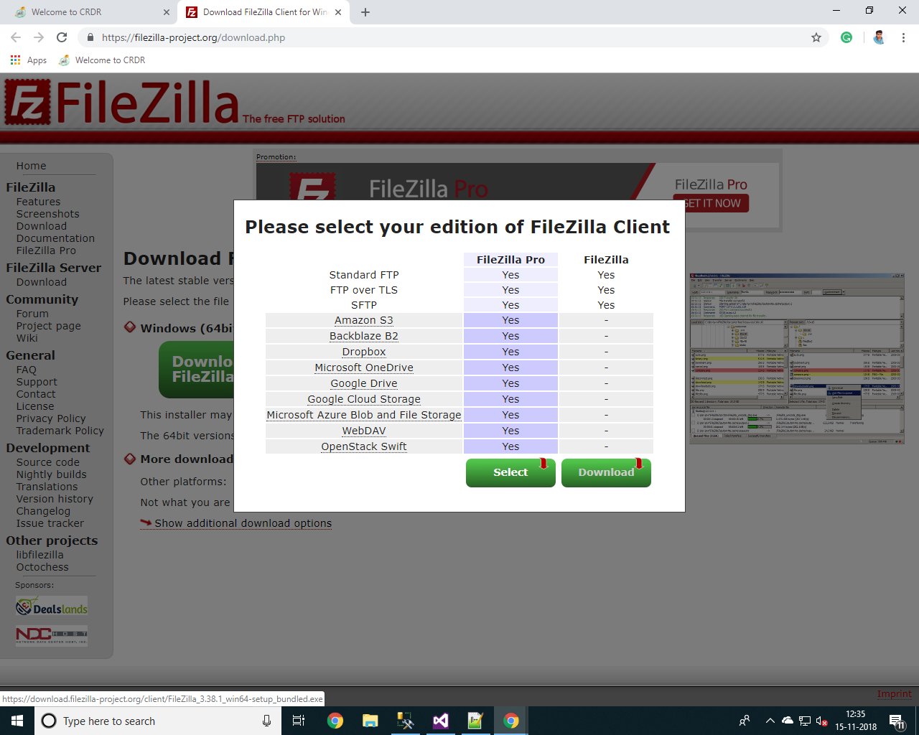

Result:- Pass.

Step 6 :- The FileZilla Set up file will be downloaded .

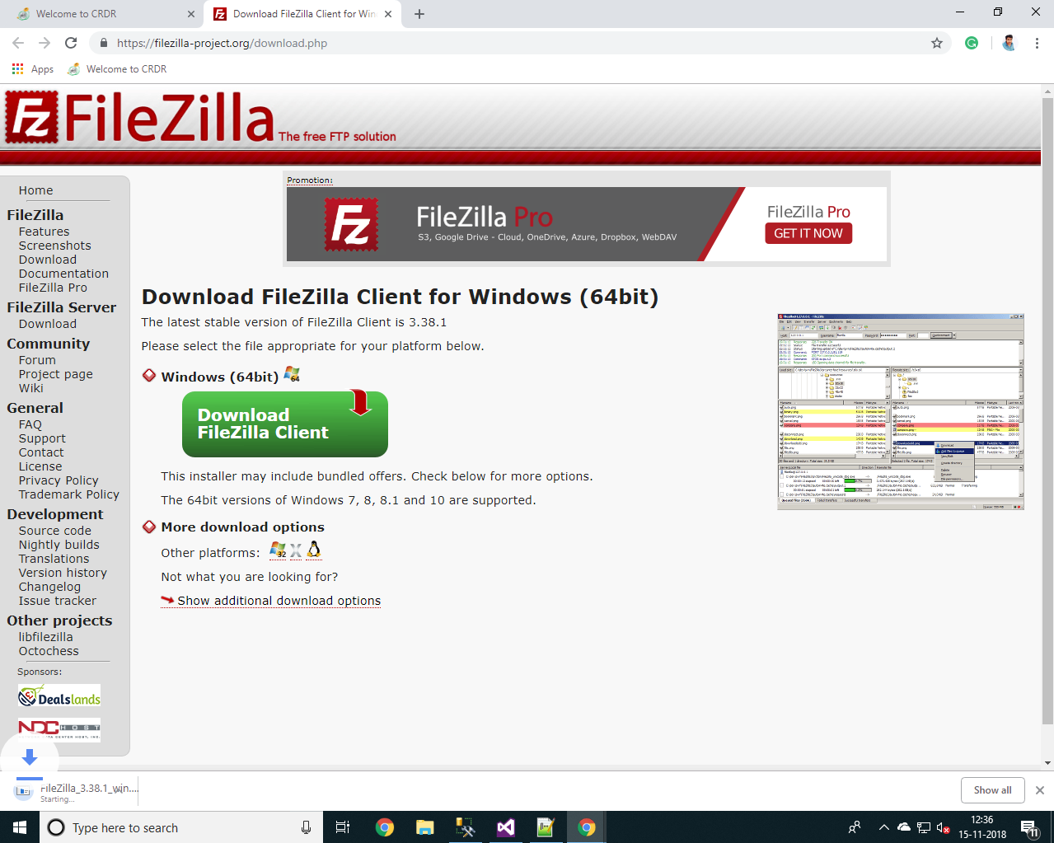

Result:- Pass.

Step 7 :- Open the FileZilla Setup file and run the file.

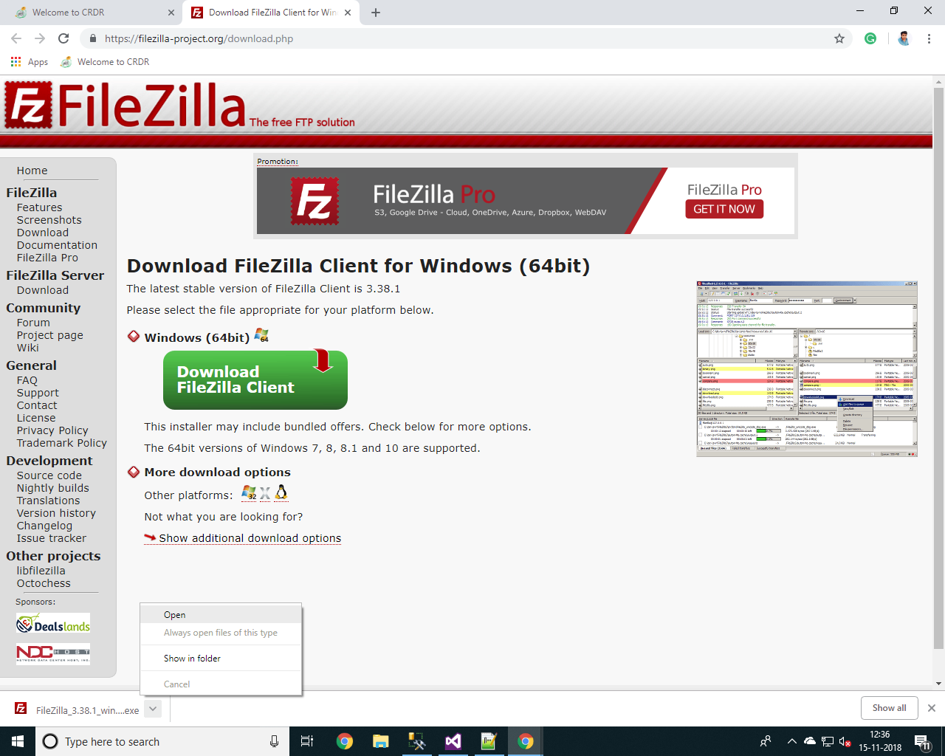

Result:- Pass.

Step 8 :- Select ‘I Agree’ from the Licence agreement and privacy policy.

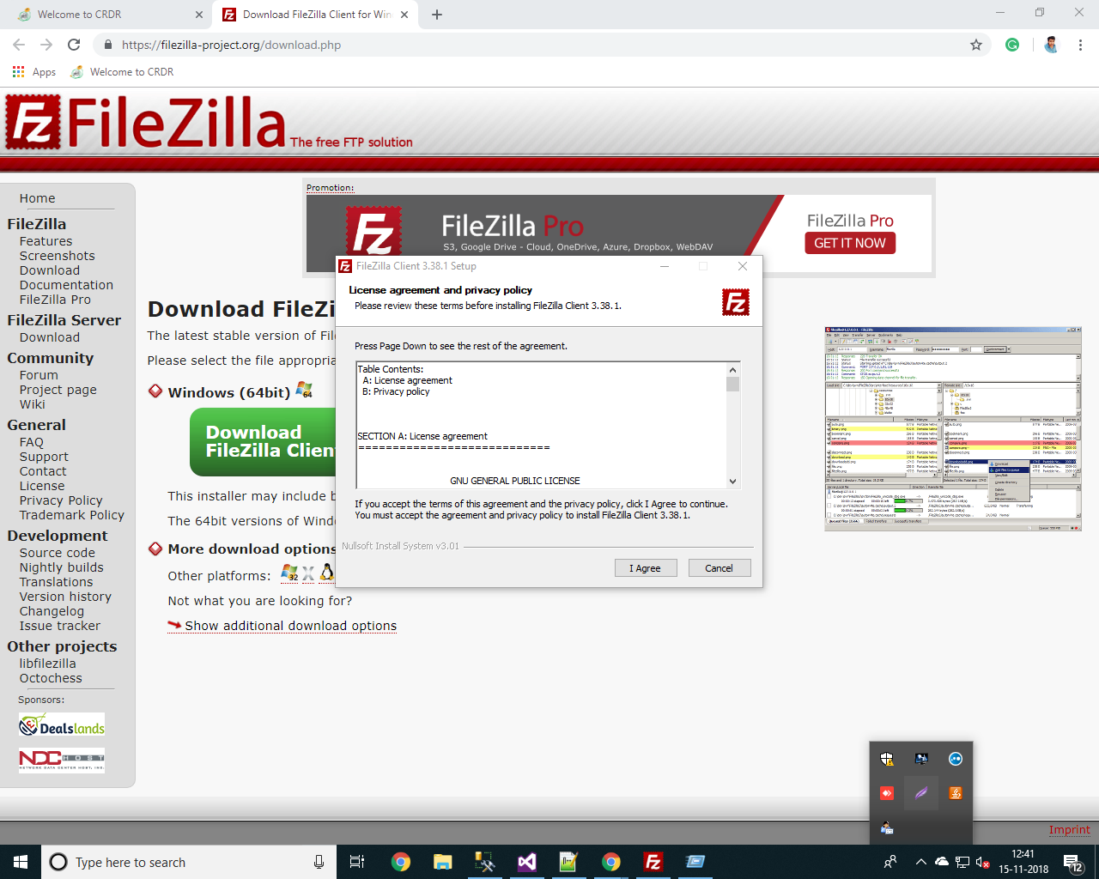

Result:- Pass.

Step 9 :- Select the options from the Installations Options and click ‘**Next >**’ button.

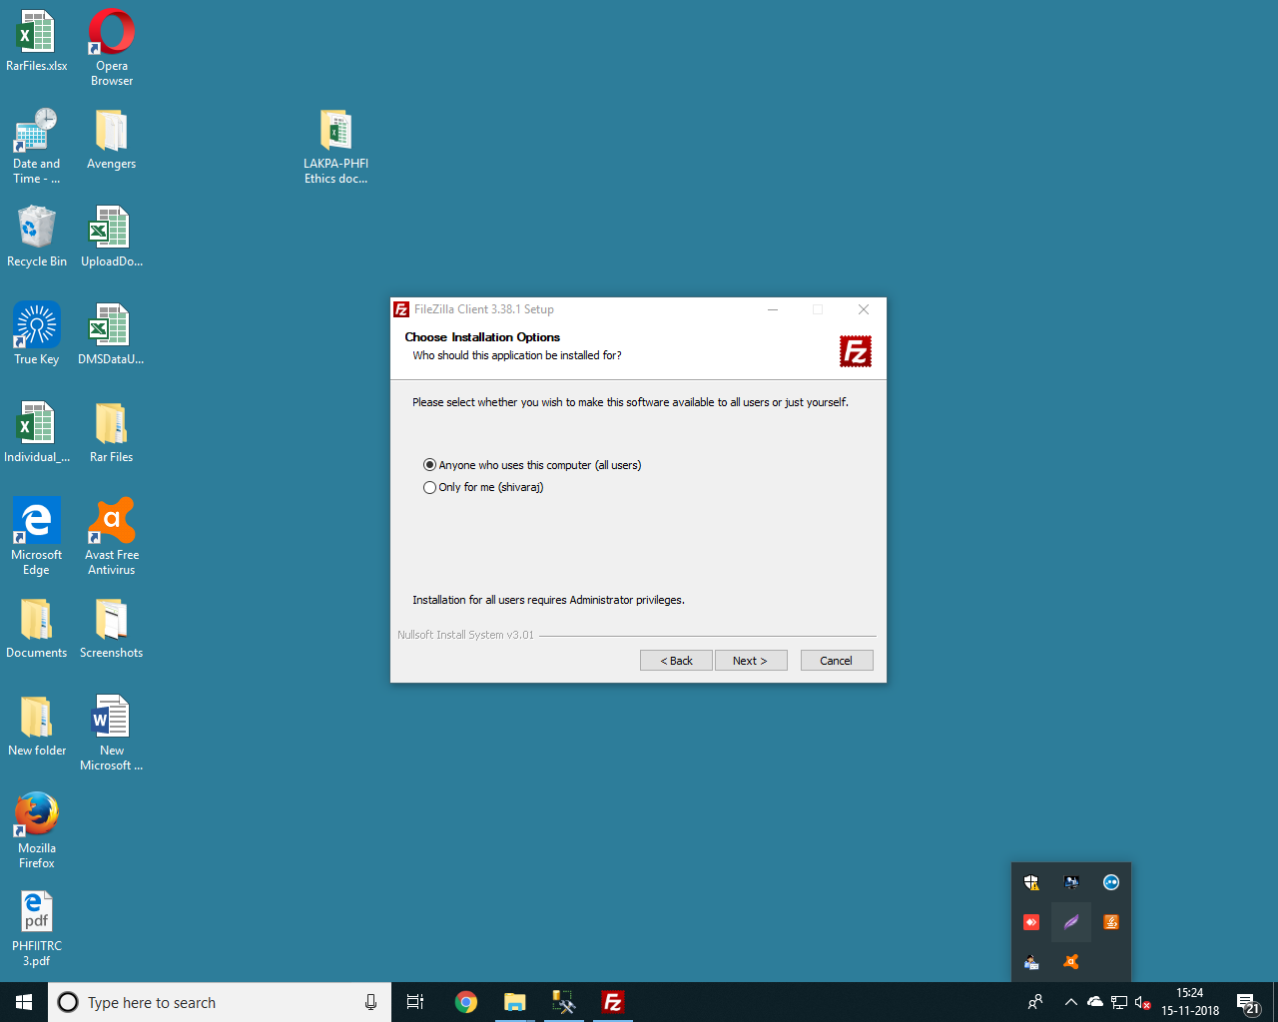

Result:- Pass.

Step 10 :- Select all the Components from the FileZilla Setup and click ‘**Next >**’ button.

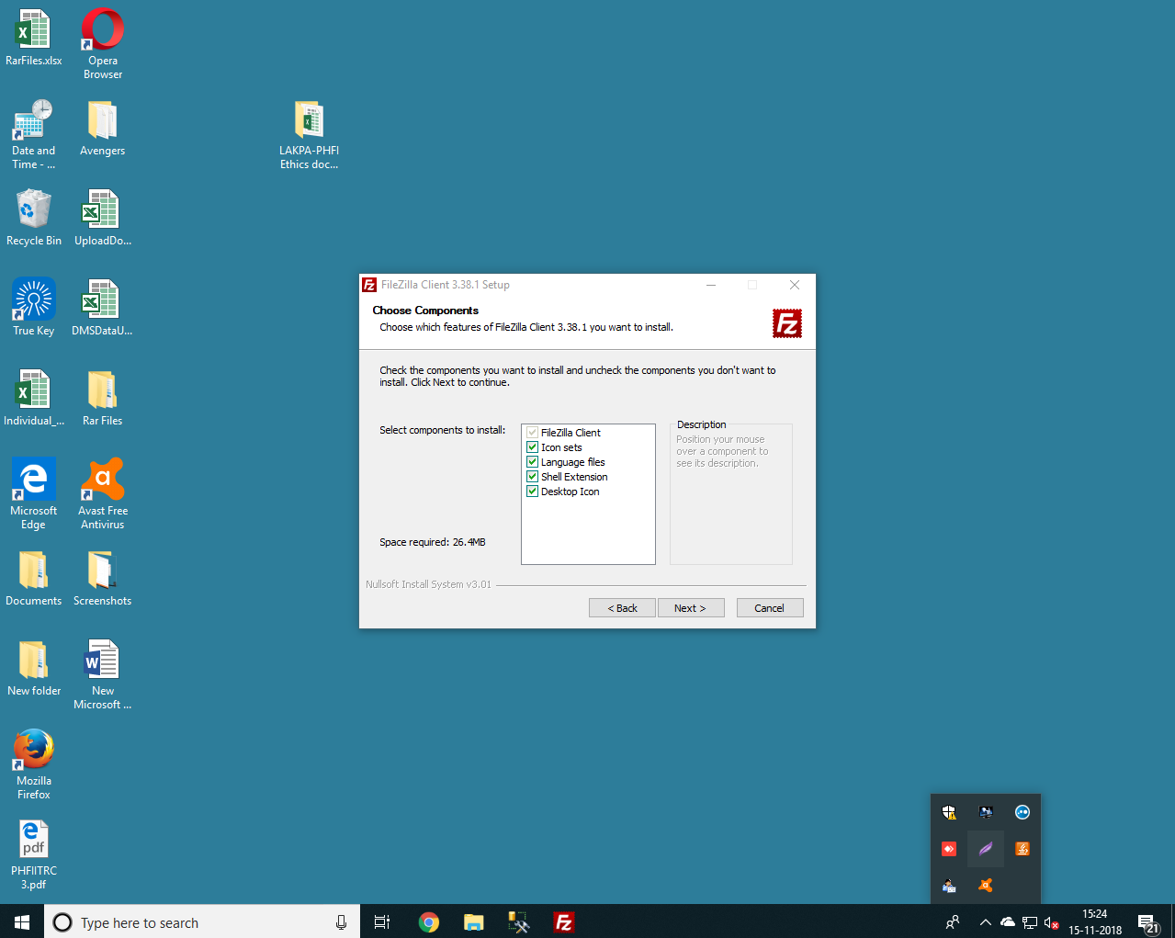

Result:- Pass.

Step 11 :- Browse and select the Destination path and click ‘**Next >**’ button from the FileZilla Setup.

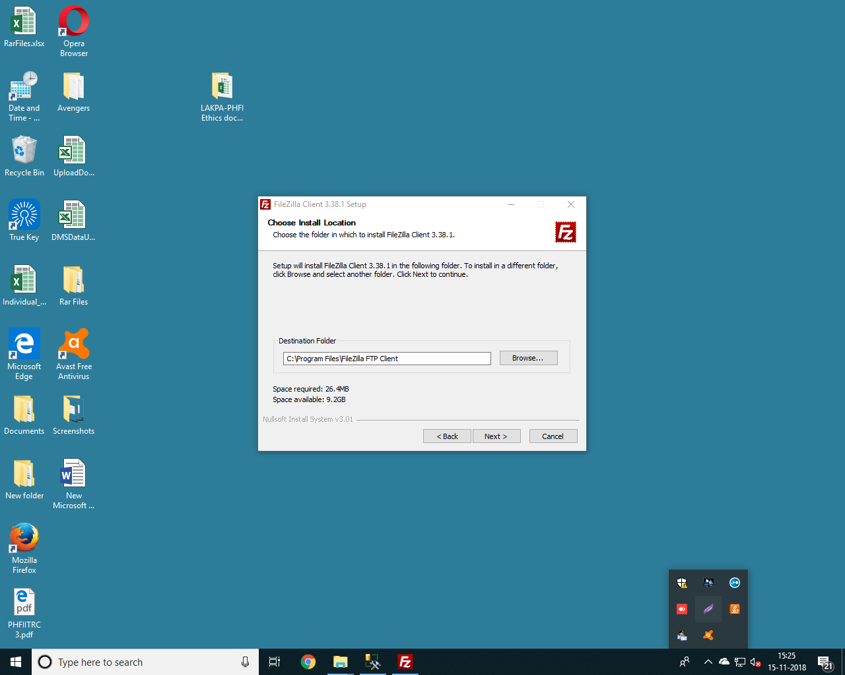

Result:- Pass.

Step 12 :- Choose the ‘FileZilla FTP Client’ from the menu folder and click ‘**Next >**’ button from the FileZilla Setup.

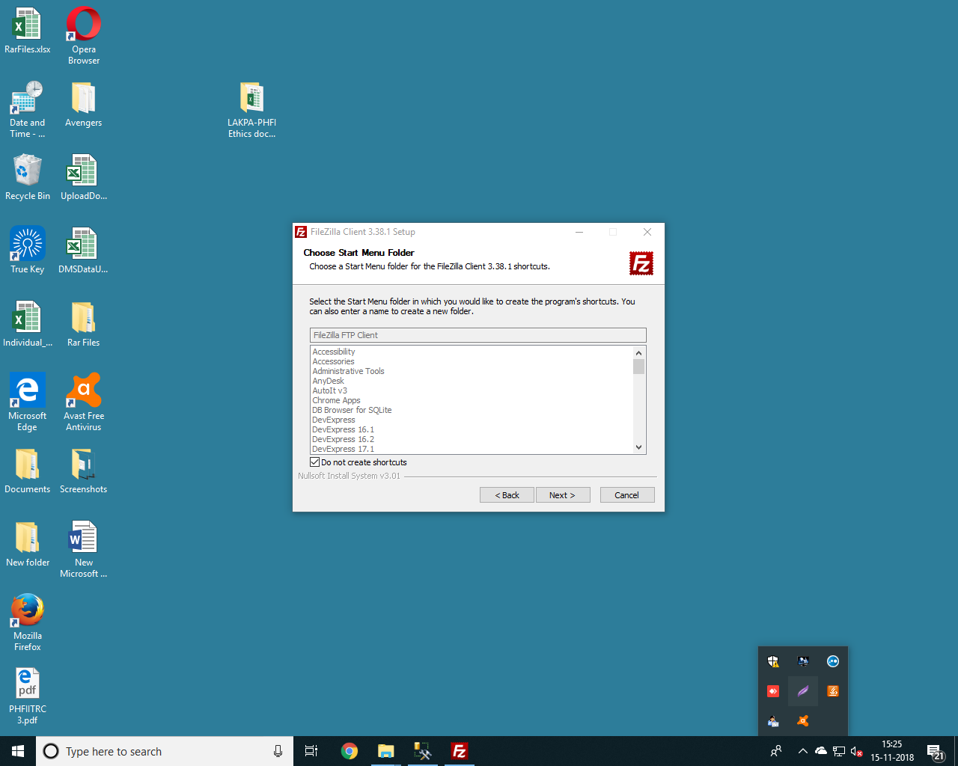

Result:- Pass.

Step 13 :-Click the ‘**Next >**’ button from the FileZilla Setup.

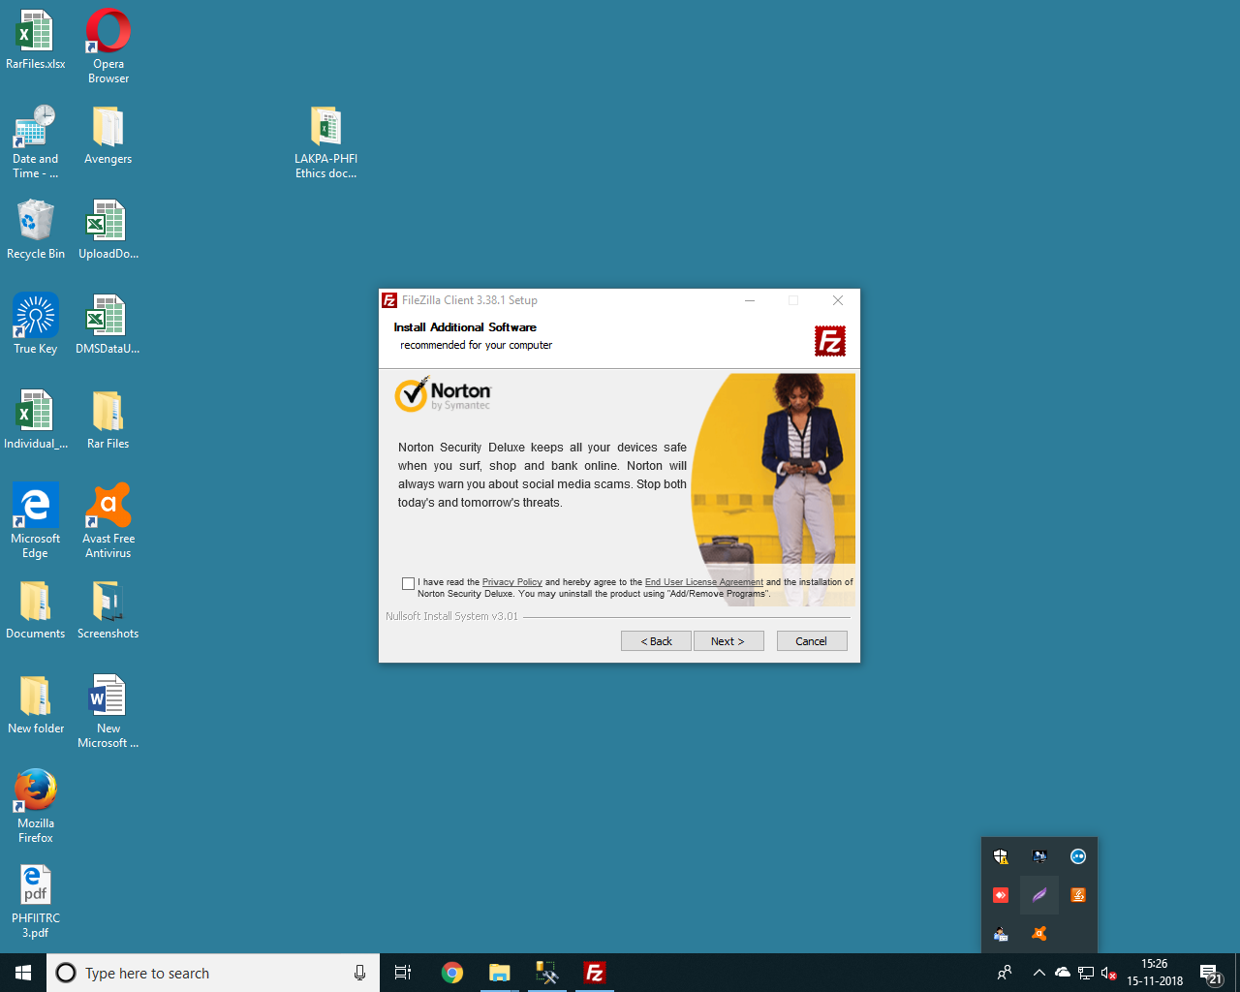

Result:- Pass.

Step 14 :-Please wait while the FileZilla Client is Installed.

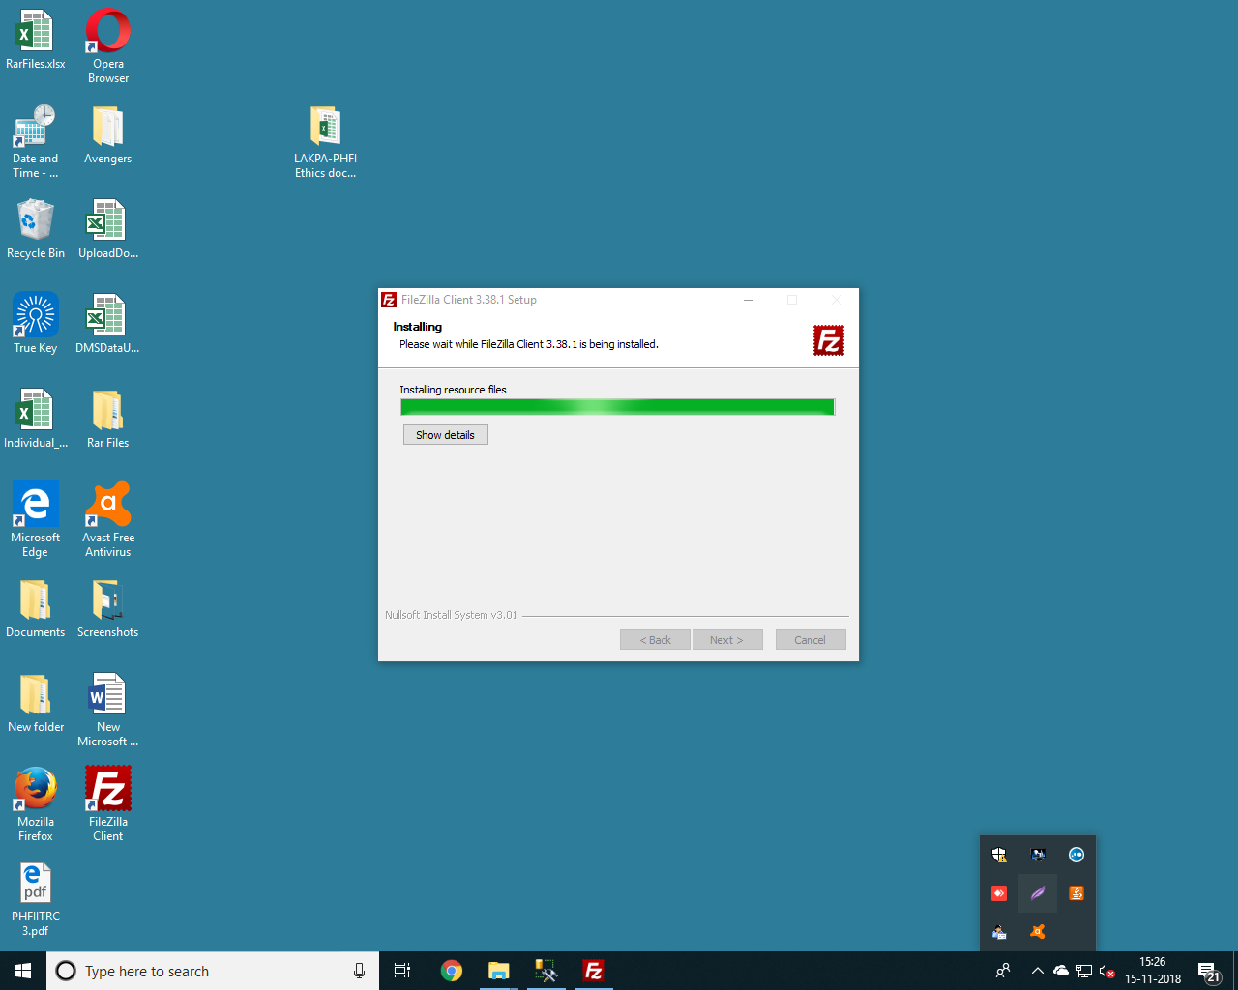

Result:- Pass.

Step 15 :-Click the ‘**Finish**’ button to finish the setup for the installation of FileZilla.

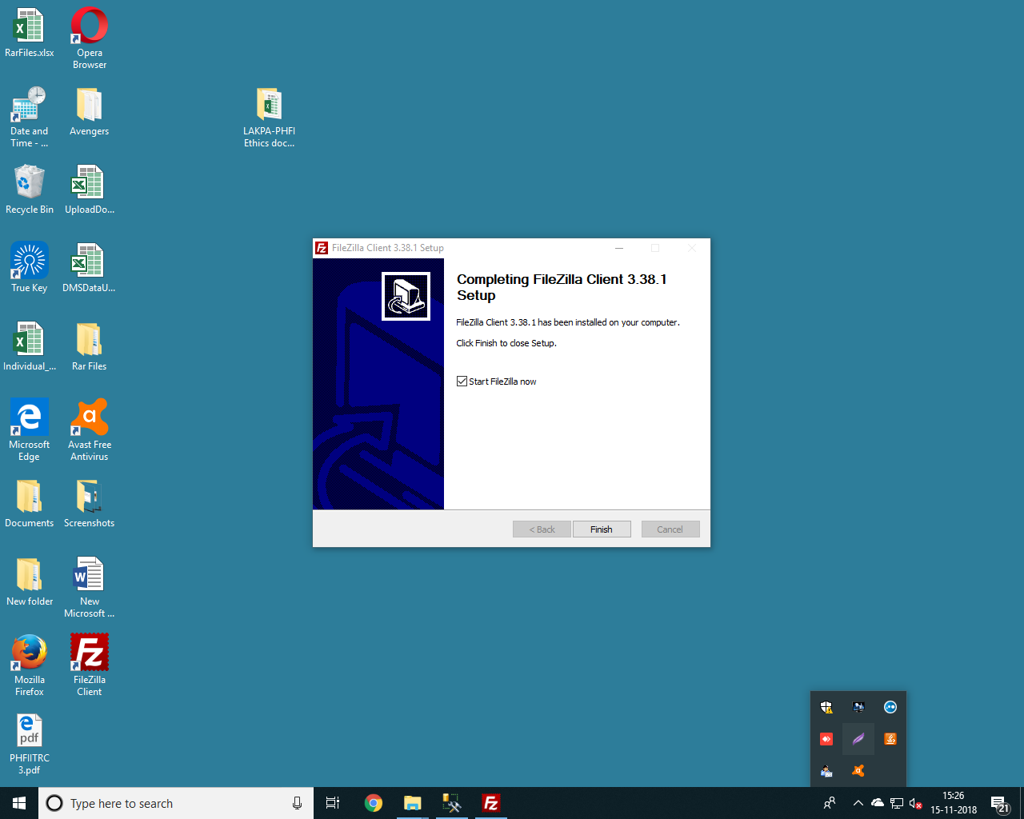

Result:- Pass.